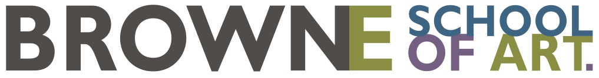

Materials list

Fluidity & Structure with Georgie Hill

A basic kit of materials to get you up and going is listed here. Specialist art shops are the best option
and will provide student discounts if you mention that you are attending the school.

The stores we recommend are:
- Studio Art Supplies: Crummer Road, Grey Lynn.
- The French Art Shop: Taylors Road, Morningside (beside Briscoes)
- Gordon Harris: Gillies Avenue, Newmarket and Symonds Street, Auckland Central
- Takapuna Art Supplies: Helensville or online

Materials to bring:

- Watercolour pad A4 - recommended: Fabriano 1264 W/Colour 300G A4 Top Spiral Pad (available at Gordon Harris and Studio Art Supplies).
- Watercolour block - recommended: Hahnemühle Hahn Harmony W/C 300G block A3
- Watercolour brushes of your choice: at least 2 different size brushes eg a small size 'round' brush and a 'mop' or 'flat' brush for washes - recommended: Da Vinci Casaneo watercolour brushes are synthetic fibre brushes that have great fluid-holding capacity but are less expensive than natural hair brushes. The Da Vinci Cosmotop spin range is also good. (The Gordon Harris website has information on these types as well as natural hair watercolour brushes).
- Your tutor will bring in some brushes to demonstrate the different varieties available.
- Painter’s tape: delicate (purple coloured tape).
- Paper towels
- Watercolours of your choice: recommended to bring a set with a range of colours from tubes or blocks (pans). The 3 primary colours are a good start and you can buy more as the course progresses. Both tube colours and pans are good (it comes down to personal preference).

This list is a general guide only. The majority (not necessarily all) of these materials may be used as students progress.

